Fig. S1 The appearance/disappearance of all observed OTUs with the development of colorectal carcinoma in the gut microbial communities of males. The vertical axis represents OTUs, and the horizontal axis represents samples from different groups. The vertical axis was sorted by OTU abundance before discarding abundance values. The black box in this figure indicates the appearance of an OTU, whereas the white box represents the disappearance of an OTU in all samples.
Fig. S2 The appearance/disappearance of all observed OTUs with the development of colorectal carcinoma in the gut microbial communities of females. The vertical axis represents OTUs, and the horizontal axis represents samples from different groups. The vertical axis was sorted by OTU abundance before discarding abundance values. The black box in this figure indicates the appearance of an OTU, whereas the white box represents the disappearance of an OTU in all samples.

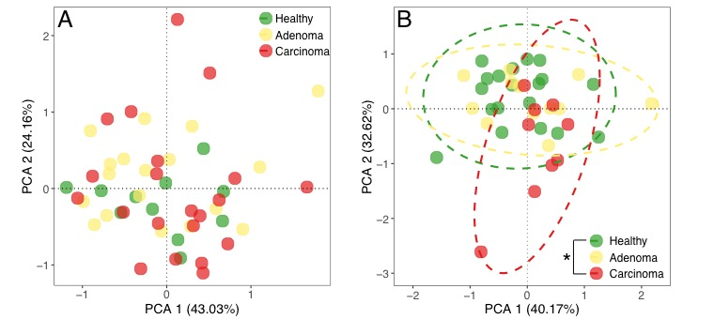

Fig. S3 Principal component analysis of network-level topological features in the male (A) and female (B) gut microbial co-occurrence networks. The differences among groups were tested using analysis of similarity(ANOSIM). * P < 0.05, ** P < 0.01, *** P < 0.001.

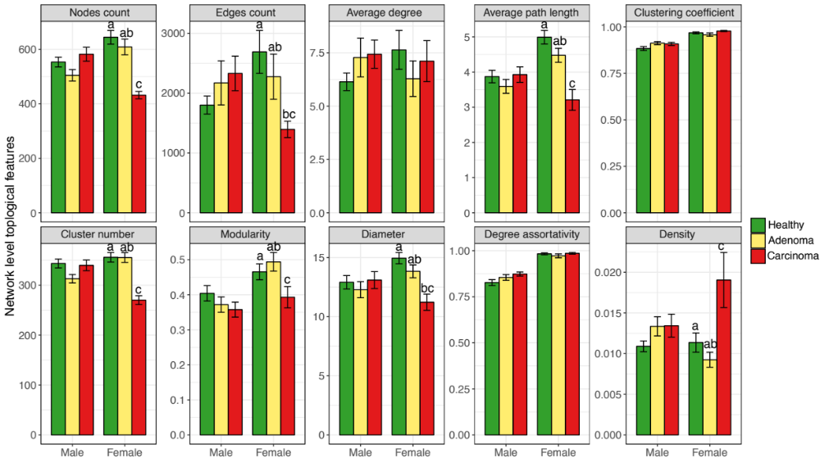
Fig. S4 The network-level topological features in the microbial subnetwork of the male and female gut with the development of colorectal carcinoma. The significance tests were carried out using a random permutation test (RPT, P < 0.05).

Tab. S1 The topological features of male and female meta-community co-occurrence networks.
Gender | NC | EC | AD | APL | CC | CN | Mo | Di | DA | De
Male | 5689 | 90760 | 31.91 | 6.61 | 0.93 | 1270 | 0.89 | 24 | 0.92 | 0.006
Female | 5522 | 77176 | 27.95 | 7.96 | 0.99 | 1191 | 0.95 | 26 | 0.99 | 0.005
NC: node counts; EC: edge counts; AD: average degree; APL: average path length; CC: clustering coefficient; CN: cluster number; Mo: modularity; Di: diameter; DA: degree assortativity; De: density

